Berkshire County Multiple Listing Service
Faxed to FBS Data on: / /
Board Office Use Only

License for Access and Use of Smart Frame IDX Links

Upon signature of the Broker holding participatory rights in the Berkshire County Multiple Listing Service (“MLS”), the MLS grants an Internet Data Exchange (“IDX”) License to facilitate the display of MLS Listings on the Participant’s or affiliated Agent’s website.

I, of am the Broker holding participatory rights in the Berkshire County Multiple Listing Service (MLS) and do hereby request;
Office: a license to utilize the IDX Smart Frame Service for my Office website
Agent: a sub-license to allow an affiliated REALTOR® to utilize the IDX Smart Frame Service
IDX License details:
Website: www.
Agent Name: MLS User Name: brk.
E-Mail: Phone:
Name of Person who maintains website:
E-Mail: Phone:

FREE IDX 1.0 (complete below) IDX 2.0 (skip to pg2) Wordpress & Mobile (skip to pg2)

IDX Link Setup details: (see page 3 for examples of the look)

Include my Photo / Logo and contact info on the left of the search box (685 pixels wide) – or –
DO NOT Include Photo / Logo and contact info on the left / Just name on the footer (400 pixels wide)

Links Requested: 3 options available

Full MLS Search Link My / my office Listings Link Public Open House Display Link
Search Page Colors
Colors shall be default greys (see page 3 for examples of the look) – or –
Border Color # Background Color #
Cont on page 2

Continued from page 1

It is understood that;
The MLS may terminate this license upon the occurrence of any of the following events:
1) Participant or Agent fails to pay any fees when due;
2) Participant or Agent discloses any confidential information, including, without limitation, passwords, source code, data;
3) Participant otherwise fails to comply in all respects with the Rules and Regulations, the applicable Board Rules and Regulations, or the Code of Ethics and Standards of Practice of the National Association of REALTORS®.

The undersigned further agree that;
- This information will be used only on the website named in this authorization form;
- The above named agent is a REALTOR® in good standing with the firm also listed above
- This website is owned and operated by the above named REALTOR®.
- The REALTOR® granted this license has received a copy of the IDX Regulations, attached herewith

I hold supervisory responsibility for the above named agent for adherence to all rules and regulations. I agree as a condition of use to familiarize myself with and abide by the governing rules of the Multiple Listing Service, the Board of REALTORS and the Code of Ethics and the National Association of Realtors®, as from time to time amended.
✗ _______________________________________________ / /
Signature of MLS Participant: Date:

I agree as a condition of a use to familiarize myself with and abide by the governing rules of the Multiple Listing Service, the Board of REALTORS and the Code of Ethics and the National Association of Realtors®, as from time to time amended.
✗ _______________________________________________ / /
Signature of Realtor® Associate, if applicable Date:

FREE IDX Options with(out) Logo / Photo on left

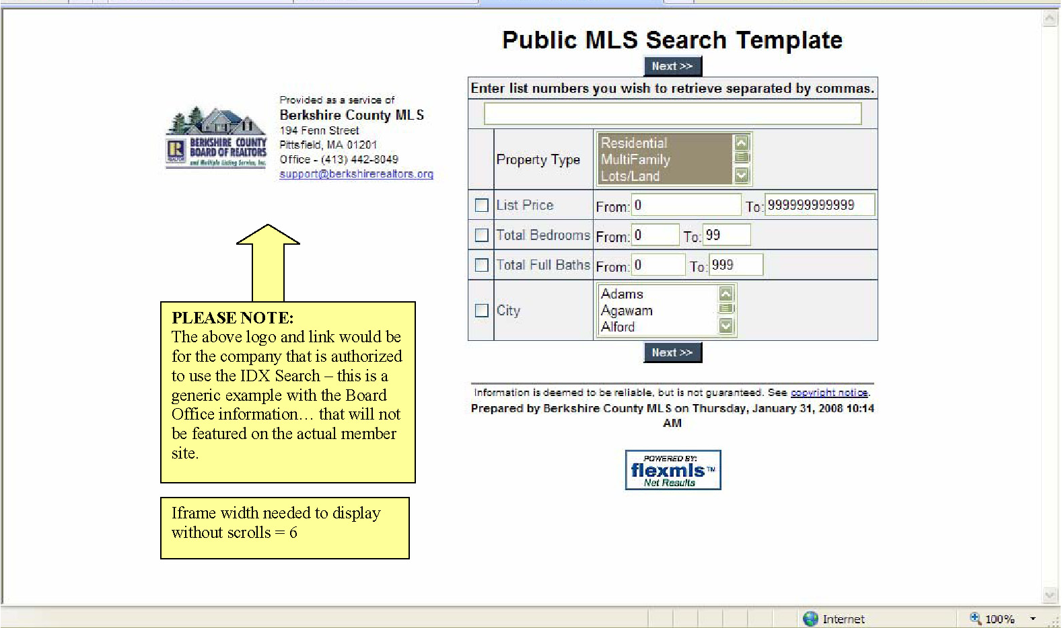

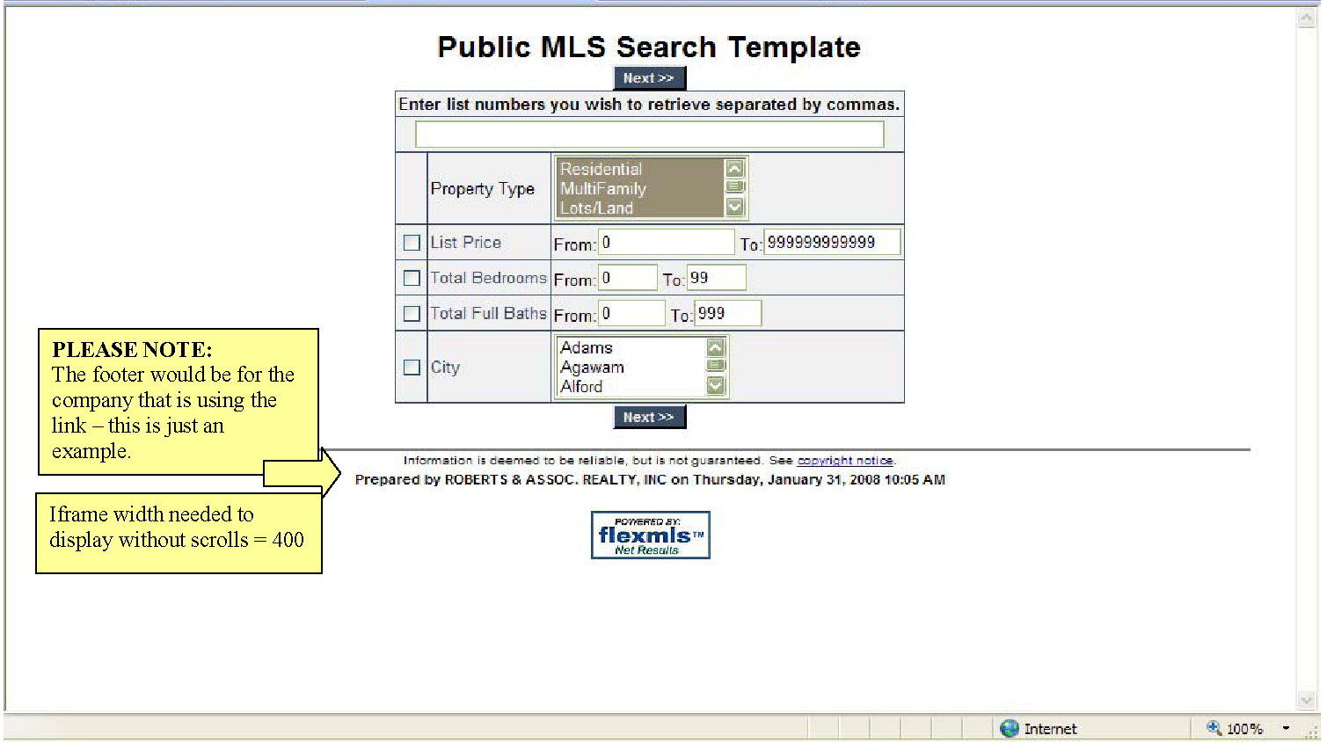

MLS Internet Data Exchange (IDX) Smart Frame
IDX Rules and Regulations – Pg. 1

Section 14 – IDX Defined: IDX affords MLS Participants the option of authorizing display of their active listings on other Participants' Internet web sites.
Section 14.1 – Authorization: Participants' consent for display of their active listings by other Participants pursuant to these rules and regulations is presumed unless a Participant affirmatively notifies the MLS that the Participant refuses to permit display. If a Participant refuses on a blanket basis to permit the display of that Participant's listings, that Participant may not download or frame the aggregated MLS data of other Participants. Even where participants have given blanket authority for other participants to display their listings on IDX sites, such consent may be withdrawn on a listing-by-listing basis as instructed by the seller.
Section 14.2 – Participation: Participation in IDX is available to all MLS Participants who are REALTORS® engaged in real estate brokerage and who consent to display of their listings by other Participants. This requirement can be met by maintaining an office or Internet presence from which Participants are available to represent real estate sellers or buyers (or both).
Section 14.3 – Display: Display of listing information pursuant to IDX is subject to the policies set forth in the Multiple Listing Service Policy Manual, as from time to time amended and incorporated in these Regulations by reference.

IDX & Smart Frame Use Requirements

- The MLS limits the right to display other Participants’ listing to licensed Real Estate Brokers who hold participatory rights in the Berkshire MLS. Participants may provide the Multiple Listing Service with a written release granting an agent in good standing with the ability to utilize the smart frame MLS solution, provided that the Participant acknowledges supervisory responsibility for said agent.
- The MLS requires that listing information displayed on a Participant’s website not be modified.
- The MLS prohibits the display of certain confidential listing information fields, when another Participant’s listings are displayed on a cooperating Participant’s website. These fields are intended for cooperating Brokers’ use, not for Consumers (see attached Matrix for specific fields prohibited).
- The MLS requires that the display of certain listing information be included when another Participant’s listings are displayed on a cooperating Participant’s website. The inclusion of this information should be displayed in a manner that is consistent with the font size and location of other standard listing information (see attached Matrix for the specific fields required).
- The MLS determined that certain listing information is optional, when other Participants’ listings are displayed on a cooperating Participant’s website (see attached Matrix for the specific fields that are optional).

MLS Internet Data Exchange (IDX) Smart Frame
IDX Rules and Regulations – Pg. 2
- The MLS requires that any display of another Participant’s listings must indicate the source of the information being displayed and, in the case of downloaded information, the most recent date downloaded. The MLS further requires that Participants refresh all downloads and refresh all data at least once every seven(7) days. Examples follow:
"Information from the Berkshire County Board of Realtors®, Inc. or its Multiple Listing Service, last updated __/__/__. Information herein believed to be accurate, but not warranted."
"All right, title and interest in the exclusively listed property information represented on this website was created, maintained and copyrighted by the Berkshire County Board of Realtors®, and in copyrights therein, shall at all times remain vested in the Berkshire County Board of Realtors®. As a Participant of the Berkshire County Multiple Listing Service, this company was granted a lease to use this information in accordance with all rules and regulations of the Service."
- The MLS prohibits sharing of the MLS database with any unauthorized third party and requires that Participants display the following language on their website where listings are displayed:
"This information is being provided for Consumers’ personal, non-commercial use and may not be used for any purpose other than to identify prospective properties Consumers may be interested in purchasing."
- The MLS has established that 24 listings is a reasonable limit on the amount of data/number of listings that Consumers may retrieve or download in response to an inquiry.
- The MLS prohibits the co-mingling of the Berkshire MLS IDX display data with that of any other listings, including but not limited to, private databases, non-listed properties or databases of any other MLS. Participants must notify the MLS of their intention to establish an IDX site and must make their site directly accessible to the MLS for purposes of monitoring/ensuring compliance with applicable rules and policies.
- Participants must protect IDX information from misappropriation by employing reasonable efforts to monitor and prevent “scraping” or other unauthorized accessing, reproduction, or use of the MLS database.
- Listings or property addresses of sellers who have directed their listing brokers to withhold their listing or property address from display on the Internet (including, but not limited to, publicly-accessible Web sites or VOWs) shall not be accessible via IDX sites. Notwithstanding this prohibition, listing brokers may display on their IDX sites or their other Web site(s) the listing or property address of consenting sellers.
- Participants may select the listings they choose to display on their IDX sites based only on objective criteria including, but not limited to, factors such as geography or location (“uptown,” “downtown,” etc.), list price, type of property (e.g., condominiums, cooperatives, single-family detached, multi-family), cooperative compensation offered by listing brokers, type of listing (e.g., exclusive right-to-sell, or exclusive agency), or the level of service being provided by the listing firm. Selection of listings displayed on any IDX site must be independently made by each participant.
- Except as provided in these rules, an IDX site or a participant or user operating an IDX site may not distribute, provide, or make any portion of the MLS database available to any person or entity.
- When displaying listing content, a participant's or user’s IDX site must clearly identify the name of the brokerage firm under which they operate in a readily visible color and typeface.

MLS Internet Data Exchange (IDX) Smart Frame
IDX Rules and Regulations – Pg. 3
- Listings displayed pursuant to IDX shall contain only those fields of data designated by the MLS. Display of all other fields (as determined by the MLS) is prohibited. Confidential fields intended only for other MLS participants and users (e.g., cooperative compensation offers, showing instructions, property security information, etc.) may not be displayed on IDX sites.
- The type of listing agreement (e.g., exclusive right to sell, exclusive agency, etc.) may not be displayed on IDX sites.
- Participants shall not modify or manipulate information relating to other participants' listings. (This is not a limitation on site design but refers to changes to actual listing data.) MLS data may be augmented with additional data not otherwise prohibited from display so long as the source of the additional data is clearly identified. This requirement does not restrict the format of MLS data display or display of fewer than all of the available listings or fewer authorized data fields.
- Each listing displayed pursuant to IDX shall identify the listing firm and listing agent on every page that listing information appears, in a readily visible color and typeface not smaller than the median used in the display of listing data.
- Participants must refresh all downloads and refresh all data at least once every seven (7) days.
- Participants (and their affiliated licensees, if applicable) shall indicate on their Web sites that IDX information is provided exclusively for consumers’ personal, non-commercial use, that it may not be used for any purpose other than to identify prospective properties consumers may be interested in purchasing, and that data is deemed reliable but is not guaranteed accurate by the MLS. The MLS may, at its discretion, require use of other disclaimers as necessary to protect participants and/or the MLS from liability.
- Listings obtained through IDX must be displayed separately from listings obtained from other sources, including information provided by other MLSs. Listings obtained from other sources (e.g., from other MLSs, from non-participating brokers, etc.) must display the source from which each such listing was obtained.
- Display of expired, withdrawn, and pending listings is prohibited.
- Display of seller’s(s’) and/or occupant’s(s’) name(s), phone number(s), and email address(es) is
prohibited.
- Participants are required to employ appropriate security protection such as firewalls, provided that any security measures required may not be greater than those employed by the MLS.
- IDX operators must maintain an audit trail of consumer activity on the IDX site and make that information available to the MLS if the MLS believes the IDX site has caused or permitted a breach in the security of the data or a violation of MLS rules related to use by consumers.

IDX Display Requirements:

The Multiple Listing Service grants all Participants, and all subscribers (upon their Participant’s written approval), a right to use a smart frame IDX solution.

Participants and subscribers are prohibited from framing the Board IDX website display, since custom links are available to the membership for free.

As outlined in paragraph 19, the requirement to include the listing firm and listing agent identifications encompass every occurrence where IDX listing information is display, including but not limited to, search results pages with listing information displayed in limited format and detail pages.
Fields marked as ‘mandatory’ MUST be displayed in the IDX listing details. Fields marked ‘prohibited’ can NOT be displayed anywhere in an IDX listing. All fields that are not shown in this list can be displayed at the IDX user’s discretion.

Main Field Name | Display Policy
MLS # | Mandatory
City | Mandatory
Listing Member | Mandatory
Listing Office | Mandatory
Street #* | Conditional*
Street Direction* | Conditional*
Street Ext* | Conditional*
Street Name* | Conditional*
*Information can be displayed only if the listing agent checked “yes” to “Show Street Name On IDX”
Contract Information | Display Policy
Assess Amt | Prohibited
BAC | Prohibited
Book | Prohibited
Exp Date | Prohibited
Limited Service | Prohibited
List Date | Prohibited
List Price | Mandatory
Location, Tax & Legal | Display Policy
Map Ref | Prohibited
NAC | Prohibited
Page | Prohibited
SAC | Prohibited
Seller(s) | Prohibited
General Description | Display Policy
Acres Apx | Mandatory
Directions | Prohibited
Office Remarks | Prohibited
Realtor.com Type* | Prohibited
Realtor-to-Realtor | Prohibited
Showing Instructions | Prohibited
Telephone Pole Coord | Prohibited
Total Bedrooms | Mandatory
Total Baths | Mandatory
Approved October 2008, Deadline for Compliance by membership: 3/31/09.

Agent Helpful Hints When Building a Website
Legal Disclosure Compliance
"Licensed Firm Disclosure" means advertising or messaging that contains the following information:
- the firm’s name as registered with the regulatory agency of the jurisdiction(s)that licensed it to do business (abbreviations not permitted),
- the city and state / province in which the firm’s main office is located, and
- the states / provinces in which the firm holds a real estate brokerage license.
"Licensee Disclosure" means advertising or messaging that contains the following information:
- the licensee name,
- the name of the firm with which the licensee is affiliated as that firm’s name is registered with the regulatory agency of the jurisdiction(s) that licensed it to do business (abbreviations not permitted)
- the city and state / province in which the licensee’s office is located, and
- the states / provinces in which the licensee holds a real estate license.

The Web
- Whenever a licensed entity owns a Web "page" or controls its content, every viewable page should include (or link to) a full disclosure (shown above)
- A licensed entity advertising or marketing real property on a site on the Internet that is either owned or controlled by the licensed entity shall periodically, but not less than every thirty-one (31) days, review the advertising and marketing information on the site concerning real property listed by the licensed entity to assure it is current and not misleading.
- MLS Rules indicate that all IDX (shared listing data) from the MLS must be updated at least once every seven (7) days. [use of smart-frames by agents automatically update every 24 hrs each business day]
- Licensed entities may NOT display and distribute, electronically or otherwise, information about properties listed by other licensed entities UNLESS they obtain the authorization of the listing broker. This authorization may be express or, if both licensed entities participate in a cooperative service, may be set forth in the rules of the MLS Service. (IDX)
- Licensed entities may not alter the online display or any information about the listing without the written permission of the listing broker.
    - E-mail, Newsgroups, Discussion Lists, Bulletin Boards
- Such formats should include a full disclosure at the beginning or end of each message.
    - Instant Messages
- Full disclosure is not necessary in this format if the licensed entity provided the written full disclosures via another format or medium (e.g., e-mail or letter) prior to providing, or offering to provide, licensable services.
    - Chat
- Full disclosure prior to providing, or offering to provide, licensable services during the chat session or in text visible on the same Web page that contains the chat session if the licensed entity controls the Web site hosting the chat session.
    - Multimedia Advertising (e.g. Web based, executable e-mail attachments, etc.)
- Full disclosure should be visible as part of the advertising message, including banner ads..

What am I supposed to do?

Excerpted from a presentation by David Staebler, below is a list of strategies Realtors® can practice to avoid the pitfalls of Internet listing.

- Don’t Let Simple Stuff Get You In Trouble
- Identify brokerage on every page
- Co-brand properly
- Don’t advertise stale data or adopt misleading identity
- Be wary of web distribution
- Nothing is Free
- Know where your data goes
- Know what you get in return for your data
- Know Where You Are Going
- Know what you want from the Internet before you invest in it
- Regularly review and reassess your goals
- Assess whether technology is part of the solution or part of the problem
Use of REALTOR® on the Internet
Here is a brief list of the principle rules affecting use of the REALTOR® marks in domain names:
1. The term REALTOR®, whether used as part of a domain name or in some other fashion must refer to a member or a member's firm.
2. The term REALTOR® may not be used with descriptive words or phrases. For example, Number1realtor.com, numberone-realtor.com, chicagorealtors.org or realtorproperties.com are all incorrect.
3. For use as a domain name or e-mail address on the Internet the term REALTOR® does not need to be separated from the member's name or firm name with punctuation. For example, both johndoe-realtor.com and johndoerealtor.com would be correct uses of the term as a part of domain names.
4. The REALTOR® block R logo should not be used as hypertext links at a web site except to the National Association's web site, REALTOR.org, or its official property listing site, REALTOR.com.
5. Consider adding the fair housing logo and disclaimer on any page where property is listed for sale, or where real estate services are offered and described.

